**Thai Massage**

Thai massage is believed to have been developed by Jivaka Kumar Bhaccha, physician to Buddha, more than 2,500 years ago in India. **Thai massage is also called Thai yoga massage**, because the therapist uses his or her hands, knees, legs, and feet to move you into a series of yoga-like stretches. Many people say Thai massage is like doing yoga without any work.

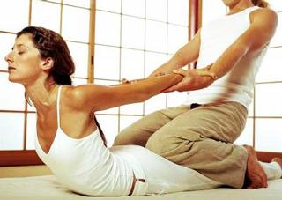Thai massage is more energizing and rigorous than more classic forms of massage. Muscle compression, joint mobilization, and acupressure are also used during treatment. People describe Thai massage as both relaxing and energizing. **Thai massage is usually done on a padded mat on the floor. No oil is applied, so you are fully dressed.** You are usually asked to bring or wear comfortable clothing to the massage.

The massage practitioner leans on the recipient's body using hands and usually straight forearms locked at the elbow to apply firm rhythmic pressure. **The massage generally follows the Sen lines on the body** — somewhat analogous to meridians or Channel (Chinese medicine) and Indian nadis. Legs and feet of the giver can be used to fixate the body or limbs of the recipient. In other positions, hands fixate the body, while the feet do the massaging action.

A full Thai massage session includes **rhythmic pressing and stretching of the entire body**; this may include pulling fingers, toes, ears, cracking the knuckles, walking on the recipient's back, and arching the recipient's into bhujangasana or (cobra position). There is a standard procedure and rhythm to this massage.

Chair Massage  
Swedish Massage  
Shiatsu Massage  
Thai Massage

**Home** 